You are given an m x n matrix of characters box representing a side-view of a box. Each cell of the box is one of the following:

* A stone '#'
* A stationary obstacle '*'
* Empty '.'

The box is rotated **90 degrees clockwise**, causing some of the stones to fall due to gravity. Each stone falls down until it lands on an obstacle, another stone, or the bottom of the box. Gravity **does not** affect the obstacles' positions, and the inertia from the box's rotation **does not**affect the stones' horizontal positions.

It is **guaranteed** that each stone in box rests on an obstacle, another stone, or the bottom of the box.

Return *an*n x m*matrix representing the box after the rotation described above*.

**Example 1:**

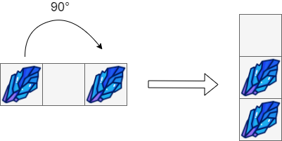

**Input:** box = [["#",".","#"]]

**Output:** [["."],

  ["#"],

  ["#"]]

**Example 2:**

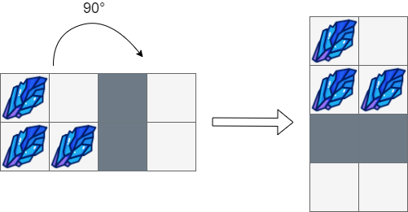

**Input:** box = [["#",".","*","."],

  ["#","#","*","."]]

**Output:** [["#","."],

  ["#","#"],

  ["*","*"],

  [".","."]]

**Example 3:**

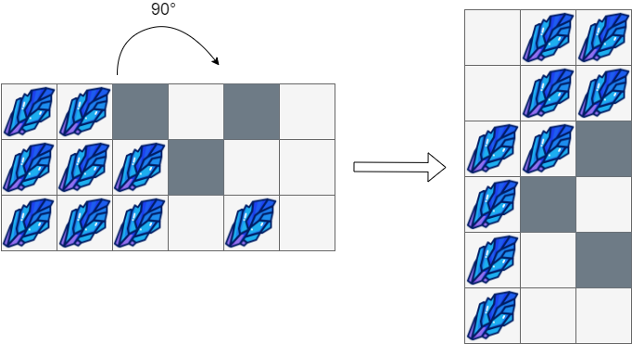

**Input:** box = [["#","#","*",".","*","."],

  ["#","#","#","*",".","."],

  ["#","#","#",".","#","."]]

**Output:** [[".","#","#"],

  [".","#","#"],

  ["#","#","*"],

  ["#","*","."],

  ["#",".","*"],

  ["#",".","."]]

**Constraints:**

* m == box.length
* n == box[i].length
* 1 <= m, n <= 500
* box[i][j] is either '#', '*', or '.'.